**Programmed Decisions**

The Programmed decisions in the management of an organization are concerned with the relatively routine problems. These decisions are taken in the regular course of any business operations and occur at a day-to-day frequency.  
  
These decisions are repetitive and structured in nature. They are small and have a low scope of impact.  
  
The **Information** related to these types of decisions is **readily available** and can be processed in a pre-determined manner. These demand very little time and effort as there are pre-determined decision rules and procedures for executing them.  
  
These are taken at **lower levels of management**  
*For example, a decision regarding personnel coming late to work regularly.*

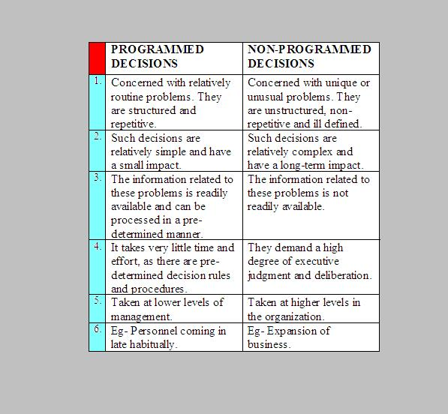

**Non-Programmed Decisions**

The Non-Programmed decisions in management are concerned with unique or unusual problems. They are encountered in a very non-frequent manner.  
  
These decisions are **unstructured, non-recurring and ill-defined** in nature. Such decisions are relatively complex and have a long-term impact.

The **Information** regarding these problems is not easily available. As such, they require a **high degree of executive judgment** and deliberation.  
  
These are generally taken at higher levels in the organization.  
*Example: Decisions regarding the expansion of business.*

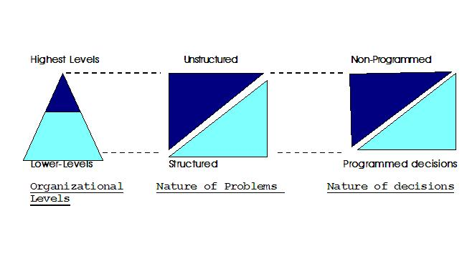

The repetitive nature of a task makes it

* Possible to discover the rule
* Desirable to apply the rule